Yahia Ragab, Mohamed Ramadan, Youssef Safwat, Youssef Ahmed, Mustafa Gomaa
Java Parallel Matrix

Abstract
This project implements and evaluates parallel matrix multiplication in Java using the Fork/Join framework. A sequential baseline is provided for correctness and performance comparison. Two parallel strategies are explored: row-based and block-based decomposition, each with a configurable threshold for task splitting. The project follows an object-oriented design, separating matrix representation, multiplication logic, and benchmarking. Performance is measured across multiple matrix sizes, demonstrating the benefits and limitations of parallelization, and providing insights into speedup, scalability, and threshold sensitivity.
GitHub link: https://github.com/Yahia-Ragab/Java-Parallel-Matrix
Environment
The project is implemented in Java 17 and uses the Fork/Join framework for parallelization. It relies on standard Java libraries (java.util.concurrent for ForkJoinPool and RecursiveTask) and JavaFX for GUI visualization. The code is organized in packages: matrix for data representation and algorithms for multiplication strategies. Execution can be done in console mode (benchmarking and correctness tests) or GUI mode (interactive matrix multiplication and performance display). The environment assumes a multi-core processor to leverage parallel computation, with matrix sizes and task thresholds configurable for performance experiments.

Class diagram:
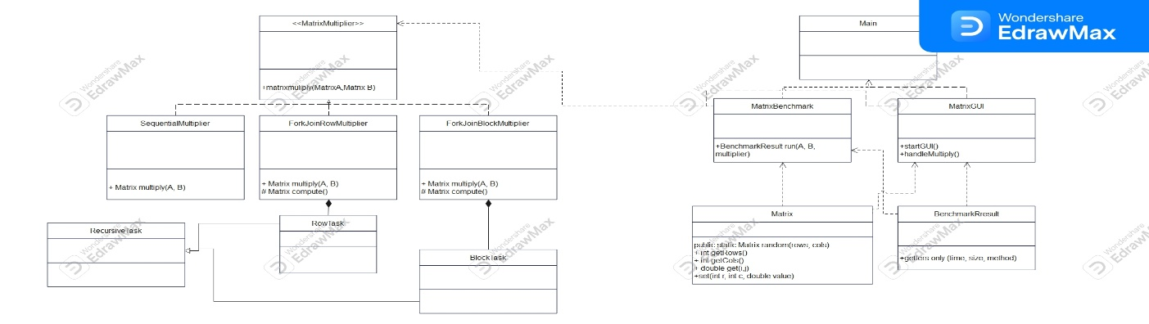Figure 1 class diagram explains the architecture of the code
How to use the app:
The code consists of two main sections “Matrix input and multiplication” and “Performance benchmark”
- Matrix input & Multiplication: Input the dimensions of the two matrices A(n, m) and B (x, y) note that m must be equal to x (m=x) else the code will throw an error, choose the algorithm form the drop down menu (Sequential, Forkjoin row-based, Frokjoin Block-based), and enter the threshold the default value is 64. Secondly ether input he matrix by your own or click on “Generate Random”. Third click on “Multiply Matrixes” button to calculate the output. At the end the result will be shown at “Result Matrix (n, y)” and “Summary and performance” shows the performance of the code: Algorithm, A (n, m), B (x, y), Result (n, y), Execution time, and threshold. Clear button for deleting the output.
- Performance Benchmark: Input the matrix size (n x n) or choose form the presets (256, 512, 1024), enter the threshold, and the algorithm Note: if you check the “Compare All Algorithms” check box you will not be able to choose the algorithm and the code will run for all algorithms depending on “number of run” you have entered.
There is 3 button: 1) Run single test, Run full Benchmark, Clear Table.
Lastly the benchmark results could be saved as CSV file.

Evaluations
- Testing environment: working on the preset matrices sizes of (256, 512, 1024), threshold 16, compare all algorithms is checked, and 6 runs
- The outputs:
For 256:
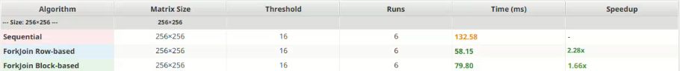Figure 2 the performance of 256 matrix .
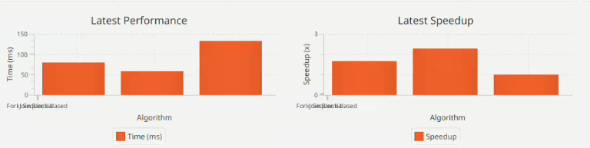
Figure 3 performance diagram for 256 matrix.
For 512:
Figure 4 performance of 512 matrix.
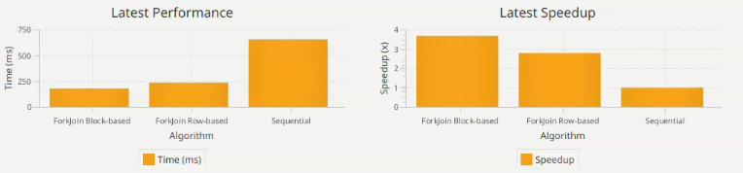
Figure 5 performance diagram for 512 matrix.
For 1024:
Figure 6 performance of 1024 matrix.
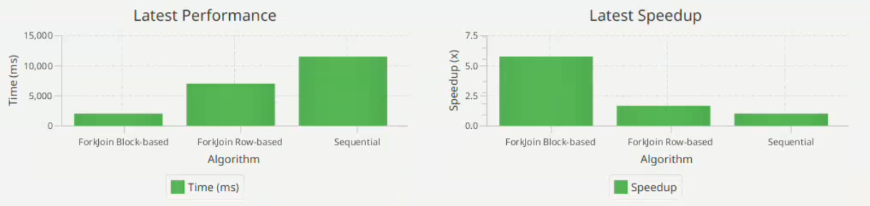
Figure 7 performance diagram for 1024 matrix.
Comparison:
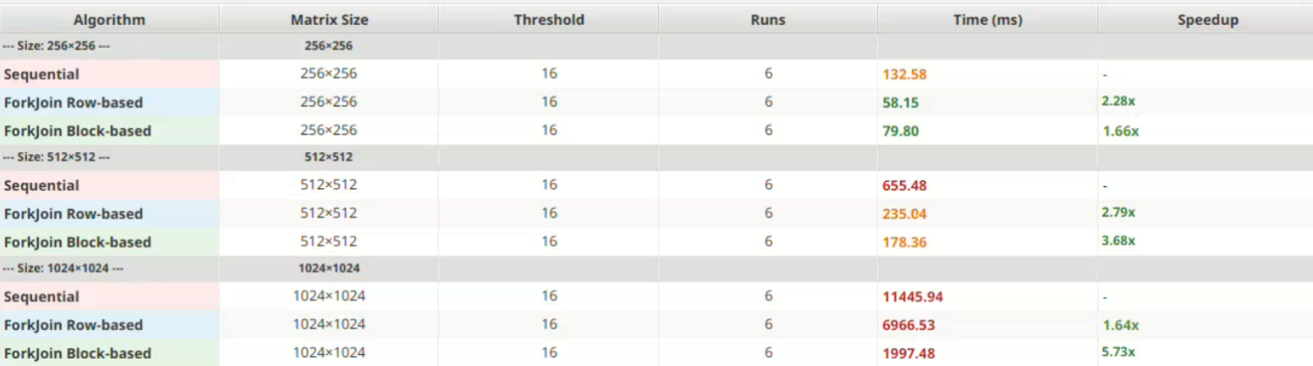
Figure 8 overall performance.
For 256×256, Sequential = 132.58 ms, Row-based = 58.15 ms, Block-based = 79.80 ms.
Row-based is fastest (2.28× speedup), while Block-based is slightly slower but still faster than Sequential.
For 512×512, Sequential = 655.48 ms, Row-based = 235.04 ms, Block-based = 178.36 ms.
Block-based becomes faster, giving the best speedup (3.68×).
For 1024×1024, Sequential = 11445.94 ms, Row-based = 6966.53 ms, Block-based = 1997.48 ms.
Block-based is dramatically faster (5.73× speedup) and clearly the best approach for large matrices.
Row-based wins for small matrices; block-based becomes much faster as size increases, giving the highest speedup overall.

Conclusion
This project successfully demonstrates the design and implementation of both sequential and parallel matrix multiplication in Java using an object-oriented structure. The Matrix class provides the core data representation, ensuring clean separation between data storage and computation. Multiplication logic is abstracted through the MatrixMultiplier interface, allowing different implementations to be easily swapped. The SequentialMatrixMultiplier offers a baseline method, while the ForkJoinMatrixMultiplier uses a RecursiveTask and a ForkJoinPool to implement a divide-and-conquer parallel strategy with a configurable threshold for task splitting. Benchmarking is handled by the MatrixBenchmark class, which generates random matrices of various sizes, runs each multiplier multiple times, and reports average runtime and speedup. Together, these components demonstrate how object-oriented design, parallel programming, and performance analysis can be combined to evaluate scalability and efficiency in matrix multiplication.

